**Report downloaded using query**

select p.branch_id,

p.cust_id,

p.cust_name,

p.pledge_no,

decode(substr(p.pledge_no, 8, 2),

73,

'Ogl',

78,

'Doorstep',

70,

'Normal',

'Others') STS1,

to_char(to_date(p.tra_dt, 'dd-mm-yyyy')) PLDT,

p.act_weight ACTWT,

p.net_weight NETWT,

p.stone_weight STNWT,

p.pledge_val PLVAL,

case

when p.cust_id = m.cust_id and m.status_id = 1 then

'OGL'

else

'NONOGL'

end STS2,

c1.created_date CRT_DT

from mana0809.pledge_master p,

mana0809.tbl_online_gl_cust_mst m,

mana0809.customer c1

where p.cust_id = m.cust_id(+)

and p.cust_id = c1.cust_id

and p.tra_dt >= '1-OCT-2022'

and exists

(select *

from MANA0809.TBL_MEETING_CUSTOMER_DETAILS t, mana0809.customer c

where (c.phone2 = substr(t.phone, -10) or

c.phone2 = substr(t.whatsapp, -10))

and c.cust_id = p.cust_id

and to_date(c.created_date) >= '1-OCT-2022'

and to_date(t.entered_on) >= '1-OCT-2022'

and p.tra_dt >= '1-OCT-2022')

**Zone wise Report**

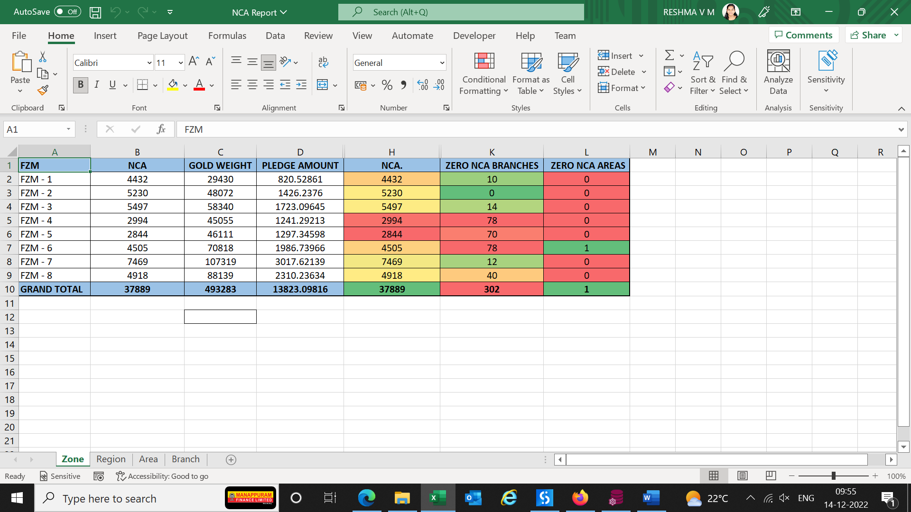

**Region wise Report**

**Area wise Report**

**Branch wise Report**

**Mail**

